**Check in:** How is school going for you? Ask each student to share if they want. This week is the first week of Ramadan. Ask the kids to share what they do during Ramadan. How is Ramadan different in America than Afghanistan?

**Warmer**: Drawing direction

* 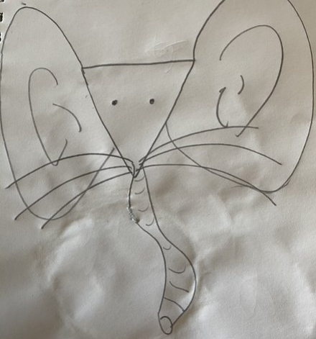Tell students to get a paper and a pen or pencil
* Tell students that they need to listen to the directions of the coaches.
  + Each coach is going to take turns giving directions. The coaches will also be drawing different things.
  + Example: Coach1 is drawing a mouse and coach2 is drawing a elephant.
    - C1: okay now everyone I want you to draw a triangle face.
    - C2: Good job everyone, now I want you to ad really big ears to the triangle.
    - C1: Now I want you to make 6 long whiskers.
    - C2: Now I want you to add a really long nose
    - C1: finally 2 small eyes.

**Homework help**: Ask the students to share their screen and show you what they are working on. If you are having trouble getting the students to share below are some questions you can ask to stimulate the conversation on what they are learning and what they may need help on.

Ask questions like:

* What homework did you have this week?
* Can you show me you English/math/ history…?
* Can you tell me about what you did in history/English/ math/ science this week?
  + Can you explain it to me?

***NOTE****: I always make 2-3 extra rooms. If you need to do some one on one homework help send me a text and I can move you or hit call host. You can also go back to the main room with the student though there may be other people in the main room.*

**Brain break game**: picker wheel

* Share screen, call on a student or students, and spin the wheel.
* You can use this 1-5 wheel and tell the kids what to do <https://wordwall.net/resource/94678/maths/wheel-spinner-1-5>
  + 1- Dance
  + 2- Jump 3 times
  + 3- Make a funny face
  + 4- Wave your arms in the air
  + 5- Spin around
* Or you can input tasks in each section of the wheel: <https://pickerwheel.com/>
  + This could also be adapted to have math equations in it
  + 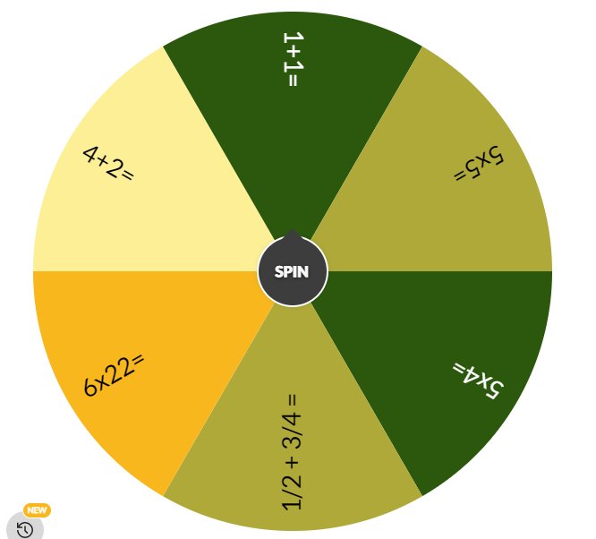

**Unlike denominators:** [**https://youtu.be/zkJ1gOrYhEg**](https://youtu.be/zkJ1gOrYhEg) **or** [**https://youtu.be/bcCLKACsYJ0**](https://youtu.be/bcCLKACsYJ0)

* **Practice:** [**https://www.khanacademy.org/math/cc-fifth-grade-math/imp-fractions-3/imp-adding-and-subtracting-fractions-with-unlike-denominators/e/adding_fractions?modal=1**](https://www.khanacademy.org/math/cc-fifth-grade-math/imp-fractions-3/imp-adding-and-subtracting-fractions-with-unlike-denominators/e/adding_fractions?modal=1)
* Below is an example of how to add fractions with unlike denominators.

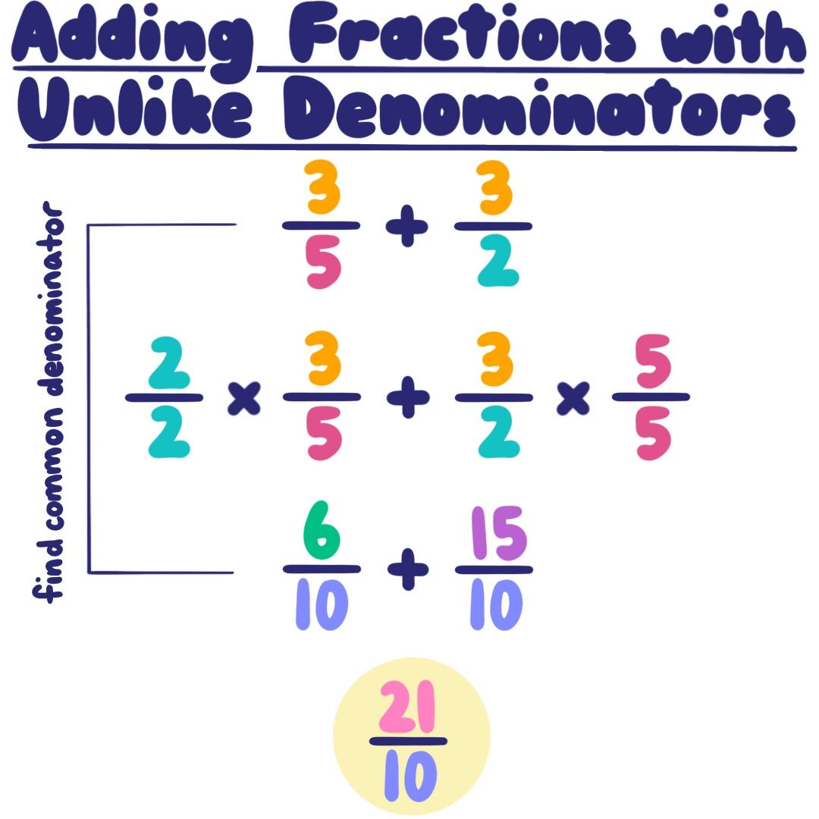

**Games:**  Kahoot! Tell your kids you are going to play a kahoot about Ramadan. Tell them that they (the students) are going to help you answer the questions and teach you about this holiday.

<https://kahoot.it/challenge/08748107?challenge-id=e21d906a-1678-4c6e-a9ee-5f26c1dc0f29_1617296392666>

Game PIN: **08748107**

**Welcome club:** Do you remember, last week we talked about **Integrity**. What does integrity mead?

**Integrity- Doing the right thing even when no one is watching. (**Popcorn ask each student what does integrity mean**)**

I am going to tell you a story: It was time for Sadaf to log into Zoom class. She was tired of doing zoom classes and wanted to go back to school. Sadaf logged into the zoom class and didn’t turn on her camara. Her teacher, Mr S. said, ‘okay class I want you to get a paper and a pencil, we are going to work on math problems.’ Ahmed asked the teacher if he could do the math in his head and not on paper. Mr S said no that everyone needed to get a paper and a pencil. Sadaf had not gotten her paper yet. Mr S. asked Sadaf, “Do you have your paper and pencil?”

**What should Sadaf say to her teacher?** (let students give feedback before options)

1. She should lie and say ‘yes I have a paper’
2. She should tell the truth and say ‘no I haven’t gotten my paper yet’

Yes, she should tell the truth. Even though Mr S. cannot see if Sadaf has a paper and pencil she should do the right thing. She should tell the truth and listen to her teachers instructions. ***When did you do the right thing in your virtual classes?***

**Wrap up** finish working on what you are working on or transition to the game.